Revised: 2013/11/10 SOS
PAC OC
Teacher’s Day Template
1. Initiation:
A position on the conference Local Organizing Committee (LOC) is established for the coordinator of the Teacher’s Day (TD) at the conference. Actions usually begin at least one year prior to the conference. As a member of the LOC work with the Conference Chair, LOC Chair, Scientific Program Committee (SPC) Chair and PAC OC guidance.
2. Program:
Teacher’s Day is usually held on Wednesday of the conference and is in parallel to other conference sessions and in a separate large room that can hold up to 50 people classroom style plus experimental equipment for demonstrations. Teachers attending TD are welcome to attend other conference sessions at their expense.
Schedule for the day usually consists of the following items. Talks and workshops are led by instructors who are charismatic, excited about work and very good at interacting with all types of questions and levels of experience. The TD coordinator needs to arrange for 5 individuals willing to be the instructors. We will cover instructor costs if they are not participating in the conference – for per diem, travel and one-night lodging. And, we cover costs of obtaining equipment for the workshops, if needed.
- 08:00 – 08:15: Obtain conference badge, if this hasn’t been done earlier.
- 08:15 – 09:00: Breakfast and announcements – meet with workshop presenters, special DPB and NPSS committee members, make connections with other physics teachers in the area.
- 09:00 – 09:45: Physics research talk
- 09:45 – 10:00: Coffee break
- 10:00 – 11:30: Hands–on demonstration workshop
- 11:30 – 12:15: Physics research talk
- 12:15 – 13:30: Lunch with up to ten (10) senior and junior accelerator scientists/engineers, in addition to the instructors and TD organizers. Discussion on why science and engineering are important for the country and what the schools can be doing to prepare the new generation for our future.
- 13:30 – 14:15: Physics research talk
- 14:15 – 14:30: Coffee break
- 14:30 – 16:00: Hands–on demonstration workshop
- 16:00 – 16:30: Certificates and demo item for taking back to class. Teacher’s fill-out assessment of day with answers to some of our questions and add their comments.

3. Costs:
Costs for Teacher’s Day are included in the conference budget. No charge to the teachers.
- Costs for the 5 instructors participating in the talks and the workshops - $3000.
- Breakfast, lunch and 2 coffee breaks - $3000.
- Item for teachers to take back to class - $3000.
- Equipment shipping/assembly/acquire for workshops - $1000.
Total $10,000.
4. Hand-outs:
- Conference badge allowing them to visit industrial exhibitors and attend sessions other than on Wednesday Teacher’s Day events.
- Conference brochure
- APS-DPB Accelerator Brochure - New 4th Edition, "Accelerators and Beams, Tools of Discovery and Innovation"
- Certificate of attendance.

5. Equipment:
Laptop, wireless mike and working wireless, speaker
6. Advertising:
Connecting to the teacher’s in the local area – high school teachers association, American Association of Physics Teachers (AAPT), school district offices, principals, notice in local schools and local university outreach program offices
7. Special Arrangements:
We could consider accommodation for those from far enough away from town for evening prior to day with us. This would be separate item for funding somehow.

Attachment examples from the Teacher’s Day held in New York, NY at NA-PAC’11, 2011 March 30:
1. Flyer for Teacher’s Day
2. Teacher’s Day Agenda
3. Continuing Education Unit Application
1. Flyer for Teacher’s Day
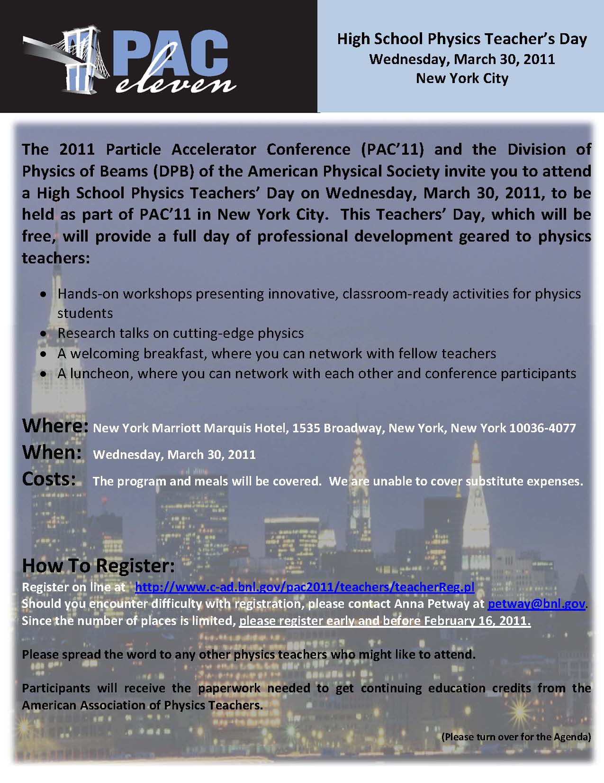
2. Teacher’s Day Agenda
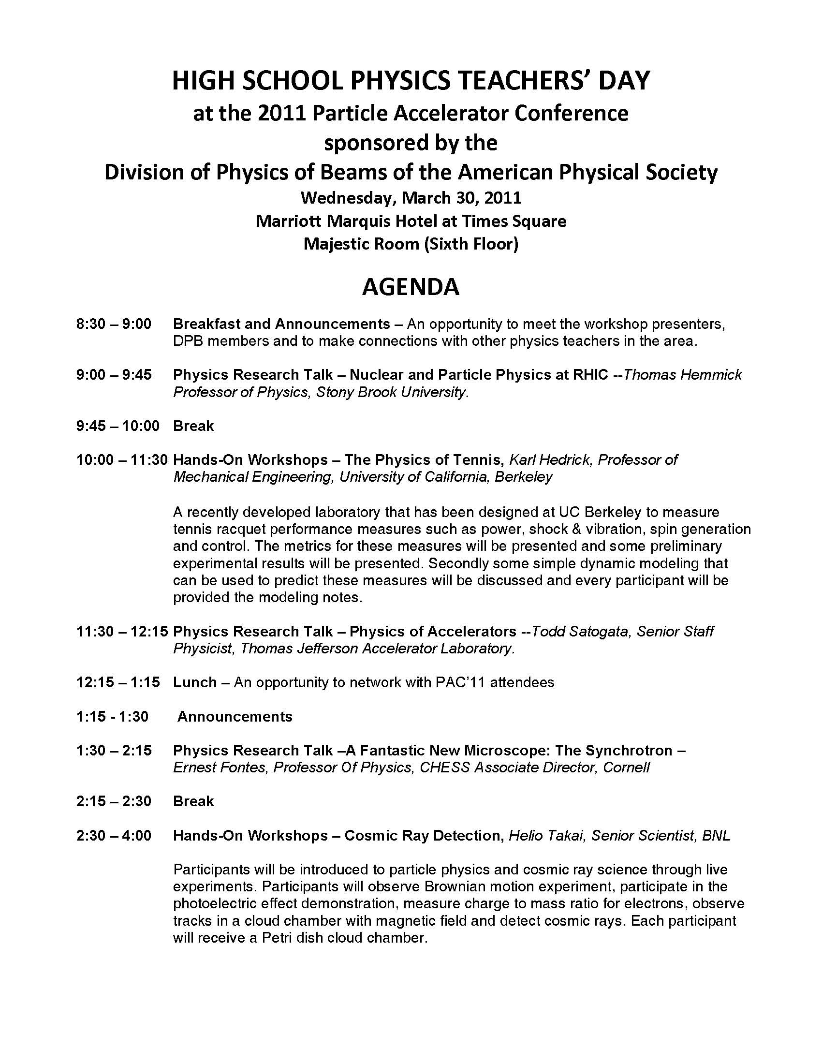
3. Continuing Education Unit Application
